Project Design Phase
Solution Architecture
Date | 5 September 2026
Team ID / Project ID | SWUID2026190359
Project Name | Metro Ticket Generating System in ServiceNow
Maximum Marks | 4 Marks

Solution Architecture:
Solution architecture bridges the identified metro ticket-booking problem and the technology solution. The architecture below shows how the passenger interacts with ServiceNow, how the booking information is processed, where station and ticket data are stored, and how the digital QR ticket is generated.
Goals of the Architecture
• Provide a simple technology solution for metro ticket booking.
• Describe the structure and behaviour of the ServiceNow-based solution.
• Define the major features, application processes and data components.
• Show how the solution is managed and delivered through the ServiceNow platform.
Solution Architecture Diagram:
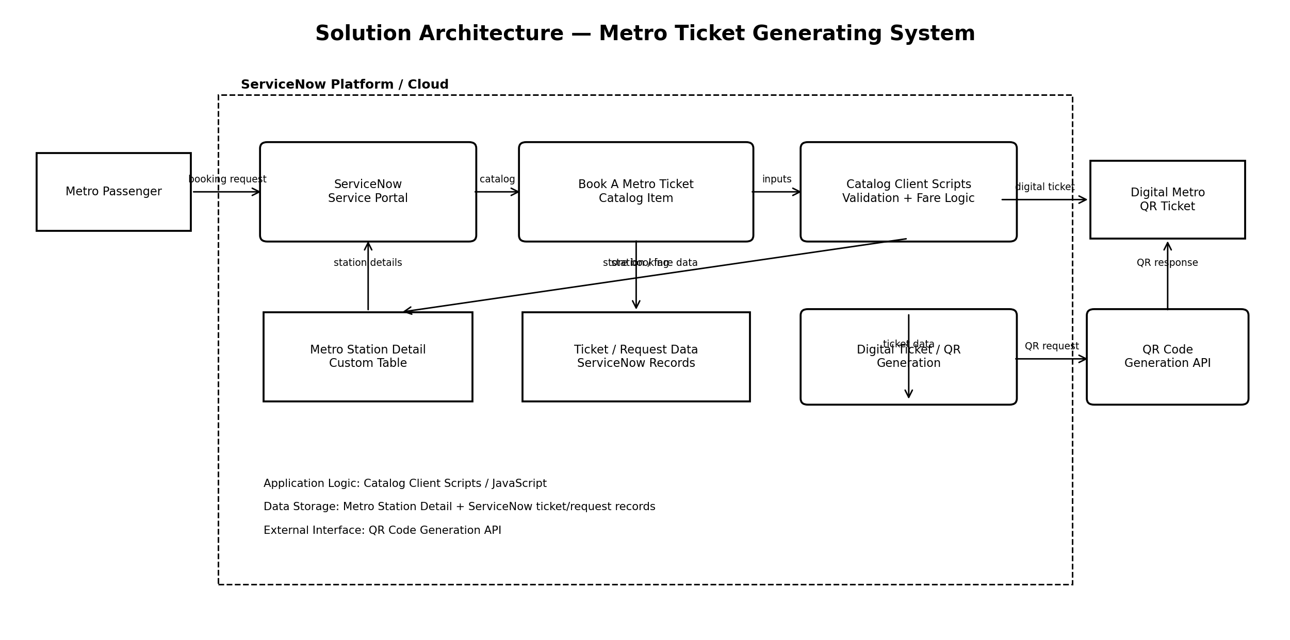
Architecture Components
Component | Purpose
Metro Passenger | The end user who enters the journey and payment details.
ServiceNow Service Portal | The user-facing interface through which the passenger accesses the metro ticket service.
Book A Metro Ticket Catalog Item | The Service Catalog item containing the metro booking form and variables.
Catalog Client Scripts | JavaScript-based application logic used for validation and automatic fare calculation.
Metro Station Detail | Custom ServiceNow table containing metro station information used for Starting From and Going To.
Ticket / Request Data | ServiceNow records containing the submitted booking and ticket information.
QR Code Generation API | External service used to generate the QR code image for the digital ticket.
Digital Metro QR Ticket | The final digital ticket presented to the passenger.

End-to-End Solution Flow
1. The passenger opens the ServiceNow Service Portal.
2. The passenger selects the “Book A Metro Ticket” catalog item.
3. The passenger selects Starting From and Going To stations.
4. The passenger selects Single Journey or Return Journey and the number of passengers.
5. Catalog Client Scripts calculate the fare automatically based on the selected route, journey type and passenger count.
6. The passenger selects UPI, CARD or Others as the payment mode.
7. The booking information is submitted and stored as ServiceNow ticket/request data.
8. The completed ticket information is used to generate a digital QR ticket.
9. The passenger receives the digital metro ticket with the QR code.
Technology Boundaries
Cloud: The main application is hosted on the ServiceNow platform. The passenger accesses the application through a web browser and ServiceNow Service Portal.
External Interface: The current project uses a QR-code generation API for creating the QR image.
Data Storage: Metro station information is maintained in the custom Metro Station Detail table, while booking/ticket information is maintained in ServiceNow records.
Machine Learning: Not applicable to the current project because fare calculation and ticket processing are rule-based.

